Workshop Report, Action Plan, and Requirements

Steering Committee:

Matzarakis Andreas, DWD

Paul Becker , DWD

Michelle Hawkins, NOAA/NWS

Stephanie Herring

Brian Jackson, UCAR

Christina Koppe-Schaller, DWD

Rupa Kumar Kolli, WMO

George Luber, CDC

Roger Pulwarty, NOAA

Jamie Shambaugh

Joy Shumake-Guillemot, WMO

Macol Stewart

Juli Trtanj, NOAA

Editors: Sarah Giltz and Hunter Jones

Report from workshop held July 28-30, 2015 in Chicago, Illinois

All presentations can be found at <https://cpaess.ucar.edu/meetings/2015/heat-health-wkshp>.

Suggested citation:

Authors:

* 0. Introduction
  + **Hunter** (lead), Juli
* 1. Extreme Heat Events - From Weather to Climate Scale Prediction
  + **Stephanie** (lead),
* 2. Public Health Decisions Across Time Scales
  + George (lead), **Sarah Giltz**!
* 3. Heat Exposure Parameters and Health Outcomes
  + **Christina** (lead), Shubhayu, Michelle
* 4. Developing a National Integrated Heat Health Early Warning System
  + **Hunter** (lead), Glenn, Joy, Christina, Kumar, Michelle
* 5. Stakeholder Engagement, Risk Perception, and Communication
  + Ned, **Vankita** (lead to be determined)
* B. Action Plan
  + **Juli** (lead), steering committee (review)
* C. Requirements
  + **Michelle** (lead)

# Table of Contents

Table of Contents

A. Workshop Report

0. Introduction and Executive Summary

Workshop Goals

Key Findings

Integrated Information Systems

1. Extreme Heat Events - From Weather to Climate Scale Prediction

Writing Assignments

Context

2. Public Health Decisions Across Time Scales

Writing Assignments

Context

3. Heat Exposure Parameters and Health Outcomes

Writing Assignments

Context

4. Developing a National Integrated Heat Health Early Warning System

Writing Assignments

Content

Bibliography

5. Stakeholder Engagement, Risk Perception, and Communication

Writing Assignments

Context

The Climate Resilience Toolkit and Climate Data Initiative

World Health Organization Heat Action Plan

System for Integrated Modeling of Metropolitan Extreme Heat Risk (SIMMER) Project

B. Action Plan

C. Requirements

Writing Assignments

Content

D. Appendices

References

Glossary

# A. Workshop Report

## 0. Introduction and Executive Summary

Oppressive weather in the form of extreme heat and humidity is a global problem. In the past several years, these extremes have touched communities around the globe, resulting in lost work hours, hospitalizations for respiratory issues, and even death. Just this past summer, extreme heat swept across Europe in July and the Middle-East and Indian subcontinent in August, triggering health consequences, energy shortages, and even protests (Valentine, 2015). Meanwhile, climate projections indicate that such extremes are only likely to be more frequent and more intense in the future (Walsh et al. 2014; Figure 1). Unmitigated, the health consequences of extreme heat will grow over time.

Figure 1: The maps show projected increases in the average temperature on the hottest days by late this century (2081-2100) relative to 1986-2005 under a scenario that assumes a rapid reduction in heat-trapping gases (RCP 2.6) and a scenario that assumes continued increases in these gases (RCP 8.5). The hottest days are those so hot they occur only once in 20 years. Across most of the continental United States, those days will be about 10ºF to 15ºF hotter in the future under the higher emissions scenario. (Figure source: NOAA NCDC / CICS-NC).

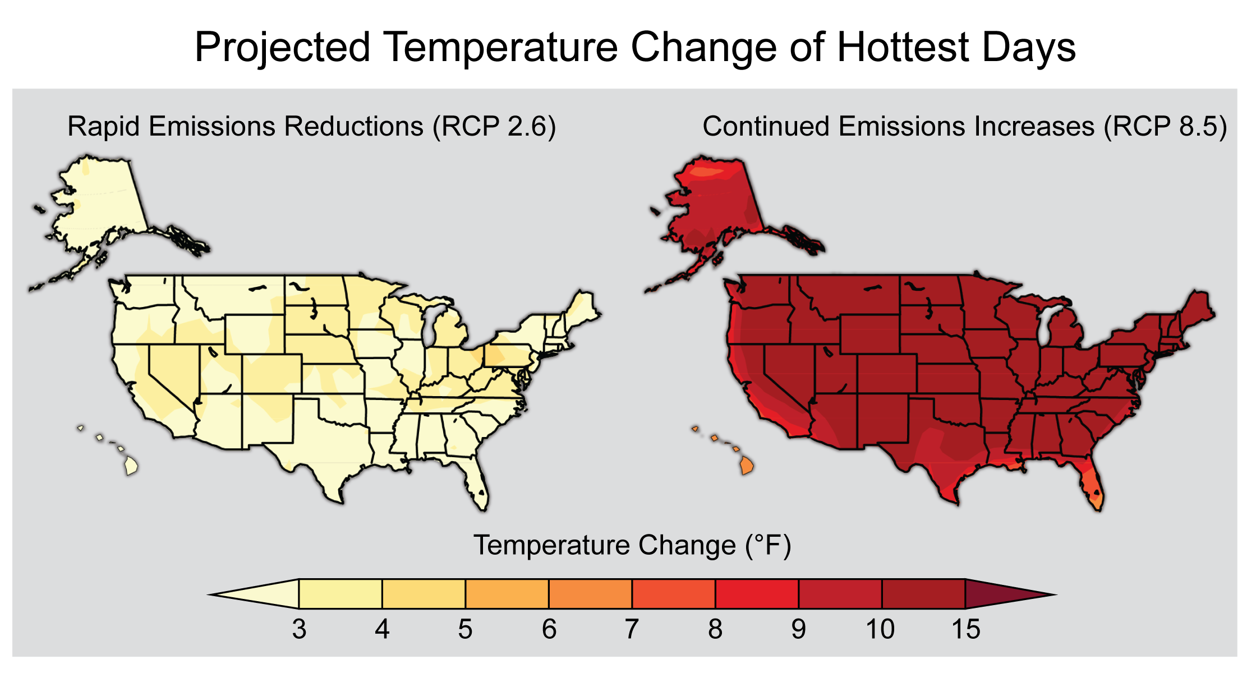

As a result of increased extreme heat predictions, cities, states, and nations are rising to the challenge of mitigating negative health outcomes. Following a deadly heatwave in 1995 that resulted in an estimated 739 deaths, Chicago invested heavily in understanding and addressing the challenge of extreme weather. Chicago is now considered a leader in the area of preparedness and response to extreme heat. Localities around the world are piloting and evaluating heat action plans and warning systems, and many have had functioning heat-health systems for several years. Each country, and in some cases state or city, approached this common problem in a slightly different way. This workshop addresses a clear need for a platform to discuss and understand these approaches and to establish dialogue between not only the early adopters of mitigative actions, but also those populations interested becoming more active in the future.

The U.S. National Oceanic and Atmospheric Administration (NOAA), Germany's Deutscher Wetterdienst (DWD), the U.S. Centers for Disease Control and Prevention, the World Meteorological Organization (WMO), and the Global Framework for Climate Services (GFCS) and partners from Environment Canada, The Indian Meteorological Service (IMS), convened this workshop on the Development of Climate Information Systems for Heat Health Early Warning in Chicago, IL, in the summer of 2015. This workshop report synthesizes the discussion during the workshop and next steps for enhancing resilience to extreme heat amongst participants and new future partners.

### Workshop Goals

* Exchange information, best practices and lessons learned on developing heat health forecasts relative to health outcomes. Discuss related planning decisions on weather and climate time scales, as well as systems for delivering heat health early warning.
* Engage key public health scientists and decision makers to refine needs for developing and delivering climate information for heat health early warning.
* Characterize prediction parameters based on geography and human exposure risk, leading to eventual harmonization of methods. Discuss advantages and disadvantages of systems based on simple thermal indices and systems based on complex indices.
* Identify and prioritize needs for observations, monitoring, data, forecast products and research to improve heat health early warning systems.

**Expected Outcomes**

* Knowledge assessment document describing gaps in our understanding of heat exposure and health outcomes across different timescales and geographies; observations, monitoring, data, forecast product needs, and research gaps.
* Synthesis of existing systems and their prediction parameters, i.e., What do they forecast, and does it work for the desired health outcomes measured?
* Identification of specific partnerships, dialogues or processes needed to improve existing heat health early warning systems and develop heat related climate services for the public health sector.

### Key Findings

* Long term information is useful for city planning; short term info is useful for communication and preparedness.
* Forecasts could be better incorporated into public health decision making.
* A three day lead time gives health departments time to implement plans.
* With climate change magnitude and frequency of high waves will increase, eroding adaptive capacity.
* Forecasts further in advance can provide more than contribution to triggering an alert.

### Integrated Information Systems

definition of this concept - though perhaps more thoroughly developed in later sections, it might be appropriate to define here and use as a consistent idea throughout the report.

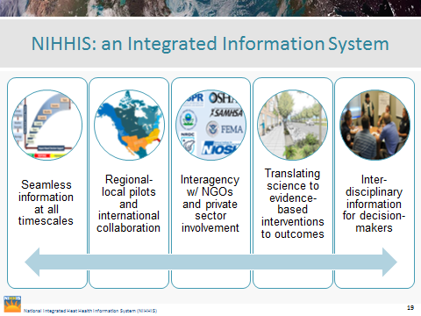

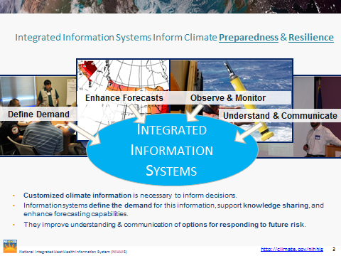

Integrated Information Systems (IISes) are designed to support and inform decision-making:

* A community of people with a shared understanding of a problem and shared goals for resolving that problem. For NIHHIS - this is
* A decision support system
* Bridging

## 1. Extreme Heat Events - From Weather to Climate Scale Prediction

### Stephanie Herring (NOAA/NESDIS)

* From Heat Warnings to Heat Pre-Information: The German Experience  
  *Paul Becker - Vice-President, Head of Business Area for Climate and Environment,   
  Deutscher Wetterdienst (DWD)*
* Global Framework for Climate Services: Heat-Health Perspectives  
  *Rupa Kumar Kolli -Officer in Charge, World Climate Applications and Services Division,   
  World Meteorological Organization (WMO)*
* Spanning the Weather-Climate Continuum  
  *Jon Gottschalck - Chief Meteorologist, Operational Prediction Branch,   
  NOAA Climate Prediction Center (CPC)*

### Context

This session reviewed the current state of projections as well as near-future capacity currently being developed to predict extreme heat at various temporal and spatial scales. Moderated by *Tim Owen - Chief, Climate and Weather Information Services at National Centers for Environmental Information, NOAA*

What can we currently predict at national and sub-national levels, and how does this vary by country? What are the current limitations and opportunities for improving projections?

### Overview

This session opened with Tim Owen from NOAA’s National Centers for Environmental Information providing an overview of the evidence demonstrating that extreme heat is a growing threat to human health. Observational data has shown that the frequency of extreme warm days has increased, and that the risk of heat stress events is rising. Projections show that temperatures will continue to increase. Owens also set up a discussion about the current suite of prediction and projection services and the right temporal and spatial scales relevant to decision makers. Current operational services include forecasts out to 14 days, seasonal outlooks, and multi-year and decade projections. There is a service gap in the seasonal to subseasonal time frame. In addition, longer term projections are only at the regional scale. Following this opening overview presentation, the session focused on the current state of prediction and projection services using examples from around the world, as well as highlighting challenges communicating prediction information and certainty levels.

**From Heat Warnings to Heat Pre-Information: The German Experience**

Paul Becker outlined the German Heat Health Warning System (HHWS). The HHWS combines numerical weather prediction and an individual human body temperature model to trigger heat warnings for the public at the county level (Figure 2). The European heatwave of 2003 caused many deaths, and in response the German government prioritized development of a seamless prediction suite on the scale of days to decades. To understand what type of information users wanted they conducted a survey which concluded that 75% of user interest was for heat information on the weather scale; 63% were interested in climate scale; 25% were interested in seasonal information; and no one was requesting decadal information.

Figure 2: Schematic of German Heat Health Warning System (HHWS).

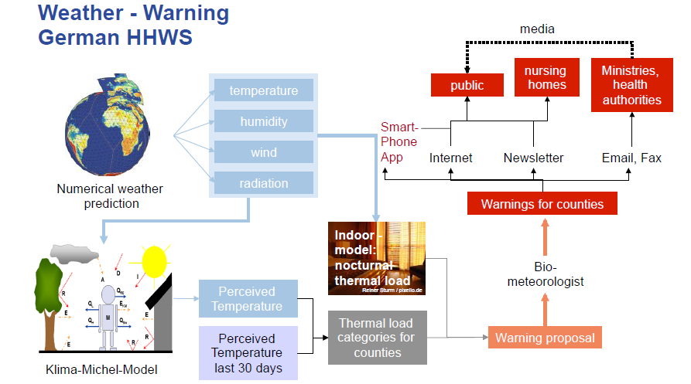

The German HHWS aims to connect the measured temperature with health effects. Perceived temperature is calculated by using a complete heat budget model that takes into account the relevant mechanisms of heat exchange for the human body. At shorter timescales of up to seven days perceived temperature forecasts can be made reliably, however at longer timescales beyond 30 days perceived temperature predictions are not reliable. The decrease in reliability is due in large part to errors in the humidity forecasts. Currently the European Centre for Medium-Range Weather Forecasts ([ECMWF](https://www.ecmwf.int/en/forecasts)) three month mean is used for seasonal forecasts, but a prediction this coarse is not readily applicable to many societal issues. In the United States, the El Niño / Southern Oscillation (ENSO) influences weather patterns and allows for improved seasonal predictability, but in Germany there are no drivers of this type for predictive models on the seasonal or decadal scale.

The German HHWS incorporates an important next step layering heat risk with demographic information including population size and age. Downscaling climate information and integrating it with socio-economic information is a continuing priority, in particular applied to urban heat projects where city-specific information is needed.

**Global Framework for Climate Services: Heat-Health Perspectives**

Rupa Kumar Kolli provided background on how the World Meteorological Organization works closely with operational meteorological services around the world to facilitate the creation of information. The [Global Framework for Climate Services](http://www.wmo.int/gfcs/) (GFCS) named human health a priority sector, and are integrating heat-health applications into relevant activities. Kolli emphasized the need to build more bridges and awareness between the heat and health sector. Climate services face an operational problem - those who most need them are unable to get them.

Figure 3: Components of Global Framework for Climate Services integration of climate services products to users.

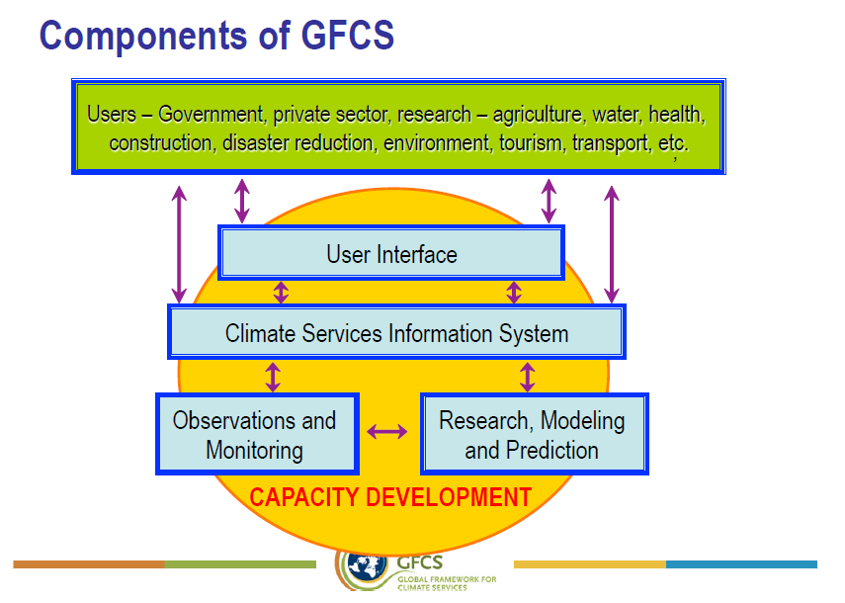

A single authoritative source for information, such as the GFCS, could facilitate the needed connections and widely disseminate information (Figure 3). The GFCS can improve the availability of useful information and improve capacity to develop heat health products. It can provide a collaborative space to define and communicate health sector needs to inform responses to climate variability and change, particularly at the national level there is a new opportunity for health to join a multi‐sector process.

**Spanning the Weather-Climate Continuum**

Jon Gottschalck from NOAA’s National Weather Service’s (NWS) [Climate Prediction Center](http://www.cpc.noaa.gov/) (CPC) provided a review of current CPC heat related products and services. CPC produces a daily U.S. hazards outlook that shows zones where there is a risk of much above or much below normal temperatures within the next two weeks, and also shows the risk of extreme heat index values (which takes humidity into consideration). Maximum heat index outlooks extend two weeks, and at the time of the workshop CPC was working on an experimental week-2 excessive heat event outlook which has since been made available on the [CPC website](http://www.cpc.ncep.noaa.gov/products/predictions/WK34/) (Figure 4). They are using reforecast datasets from [National Centers for Environmental Prediction](http://www.ncep.noaa.gov/) which do a better job handling the tails of distribution. Unlike the German HHWS the NWS CPC office does not take into account perceived heat, however local weather forecast offices sometimes include other information into their heat outlooks and warnings.

Figure 4: CPC experimental excessive heat event outlook

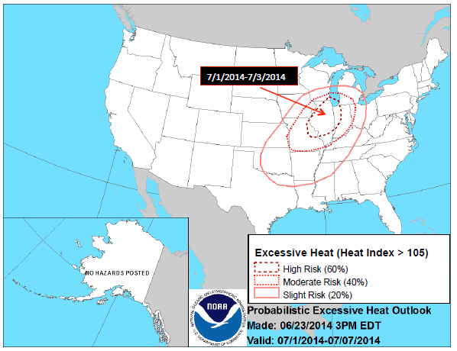

Moving toward subseasonal to seasonal (S2S) forecasts there are a few sources of predictability that modulate the probability of extremes events including the Madden-Julian Oscillation, the strength of the ENSO signal, and soil moisture. Studies looking at predictability of extremes on seasonal timescales are relatively new (since about 2010) and generally take a probabilistic approach looking at the potential number of events in a given time period.

Going beyond these shorter term multi-week outlooks Gottschalck raised some challenges, including what is an acceptable number of false alarms? CPC is engaged in ongoing research to better understand how to best utilize S2S climate patterns for excessive heat early warning information.

**Conclusions**

Forecast skill at shorter timescales (10 days and under) is quite high, however longer timescales still present challenges. Communicating uncertainty is thus more important for long-range predictions. The timescale of heat outlooks currently being provided were consistent between NOAA’s Climate Prediction Center and the Deutscher Wetterdienst. It was also clear that most groups, including the GFCS, are working on bridging the seasonal to subseasonal divide in timescales.

Though the session focused on the science of predictions, the issues of communication and application were prevalent throughout the discussion. This indicates that advancements in science are only valuable if delivery is improved along with user understanding and implementation of the information. Success is more likely if scientists integrate health partners into the beginning of the scientific process, and focus on 'co-production' of scientific information with users.

# 

# 

# **2. Public Health Decisions Across Time Scales**

## Sarah Giltz (NOAA/OAR)

### Context

This session explored the heat health decisions that health agencies must make, the spatial and temporal scale they make them on, and related information needs.  
*Moderator: George Luber - Associate Director for Climate Change, Division of Environmental Hazards and Health Effects, Centers for Disease Control and Prevention (CDC)*

* Managing Heat Risk in Arizona  
  *Matt Roach - Arizona Department of Health Services*
* Projections of Extreme Heat: Health Impacts from a Military Perspective  
  *Jean-Paul Chrétien - Armed Forces Health Surveillance Center*
* Province of Ontario (Canada) Case Study: Towards a Harmonized Heat Health Warning System  
  *Abderrahmane Yagouti, Health Canada*
* Experience with the German Heat Health Warning System in the City of Frankfurt  
  *Ursel Heudorf - Office of Public Health, Department of Medical Services and Hygiene, Frankfurt*
* Ahmedabad Heat Action Plan case study  
  *Dileep Mavalankar - Director, Indian Institute of Public Health, Gandhinagar*

How is risk assessed and managed by public health agencies? What weather and climate information are you currently using, and what additional information is needed in the future?

**Managing Heat Risk in Arizona**

The majority (95%) of heat related deaths occur between May and September. In Arizona, from 2000-2012 there were 1,535 deaths for exposure the excessive natural heat. Extreme heat also causes higher rates of hospitalizations and [emergency department visits](https://ehp.niehs.nih.gov/1306796/). Interventions to ameliorate health risk during extreme heat in Arizona include cooling centers, hydration stations, heat warning systems, and public education campaigns. [The cooling centers](https://www.maricopa.gov/DocumentCenter/View/5363) are set up largely in response to a sense of community, and are places to not only acquire water and cool off but also to gain access to food and health and human services.

Response plan activation can be based on duration of event, intensity of event, and other concurrent issues such as power failure. During an extreme heat event local Airzona public health response includes activation of the Health Emergency Operations Center (HEOC) and a [Heat Emergency Response Plan](http://www.azdhs.gov/documents/preparedness/epidemiology-disease-control/extreme-weather/heat/heat-emergency-response-plan.pdf) based on the level of the threat. The HEOC is a centralized point to deal with public health emergencies. The HEOC focuses on public communication through the [Health Alert Network (HAN)](https://emergency.cdc.gov/han/), social media, WebEOC, public heat advisory, and school heat advisory. The levels of the Heat Emergency Response Plan include heat watch, heat warning, or mass power outage. The objectives of the plan are to limit impacts to public health, identify conditions to trigger the appropriate level of response, provide framework for coordinating events, and provide a list of prevention and intervention resources. Public health exercises are implemented to help prepare the community for extreme heat.

Key scientific uncertainties about heat and health outcomes exist when trying to define the temperature “threshold” for heat illness, temperature metrics that affect health, and the determinations for heat caused illness or death. Decision making is supported by hospitalization data, deaths records, the Interactive National Weather Service (INWS), Early Warning and Response Network (EWARN), and Syndromic Surveillance. INWS is a Mobile Decision Support Service (MDSS) that allows core partners, such as emergency managers, to receive timely NWS products and timely updates via mobile devices. Syndromic Surveillance monitors disease indicators in real time and can detect outbreaks earlier than traditional methods- updated either same day, one day lag, or hourly. The [National Syndromic Surveillance Program](https://www.cdc.gov/nssp/) (NSSP) BioSense 2.0 can track excessive heat cases temporally and spatially.

In states like Arizona with hot climates, and across the global south, an average summer day is already within a heat wave range for most locations (Anderson and Bell, 2011). With increasing temperatures, urban heat islands, and equatorial population growth the heat health risks are intensifying. The focus of heat weather hazard doctrine should turn from episodic events to chronic high heat. Arizona State University and the Phoenix WHO developed an Extreme Heat Information System (EHIS). *Risk temperatures* are thresholds indicating the level of absolute heat related health risk on a given forecast day (Table 1). *Rankings* indicate relative heat related health risk compared with days in average year. The EHIS allows responders to weigh costs and benefits of situation, critical for decision making in a chronically hazardous environment. This system is complementary to the existing warning systems.

Table 1: Arizona extreme heat risk thresholds

|  |  |
| --- | --- |
| **Rankings** | **Risk Temperatures** |
| **Negligible** | Tmax < 79 °F |
| **Minimum** | Tmax > 79 °F, #239, 98% HR-mortality exceeding |
| **Increasing** | Tmax > 88 °F, #186, 97% HR-mortality exceeding |
| **Excessive** | Tmax > 104 °F, #79, 82% HR-mortality exceeding |

**Projections of Extreme Heat: Health Impacts from a Military Perspective**

The military population is younger and healthier than the population at large, but on average work in riskier conditions and do strenuous physical training. The military has monitored heat illness since the 1950s. Heat injuries spike in the continental United States in the summer, but overall have declined over the past several years. A few large installations account for most of the heat injury in the military including Fort Bragg (NC), Fort Benning (GA), and Fort Jackson (SC).

The military incorporates weather predictions into all mission and training planning and conducts its own weather and climate research. After a series of heat related deaths (198 soldiers from 1942 - 1944), the military created the [Wet Bulb Globe Temperature (WGBT)](http://ksi.uconn.edu/prevention/wet-bulb-globe-temperature-monitoring/) to incorporate measures of ambient temperature, humidity, wind, and solar radiation. Combining all these measures gives a number more relevant to how people will be affected. WGBT is used in real time to make heat health decisions. The intensity of physical exercise is determined by a color coded WGBT Index risk assessment system (Table 2).

Table 2: Military WGBT index risk assessment system

|  |  |  |
| --- | --- | --- |
| **Flag Color** | **WGBT Index (F)** | **Intensity of Physical Exercise** |
| **Green** | 80 - 84.9 | Discretion required in planning heavy exercise for unseasoned personnel. This is a marginal heat stress limit for all personnel. |
| **Yellow** | 85 - 87.9 | Strenuous exercise and activity (e.g. close order drill) should be curtailed for new and unacclimated personnel during the first 3 weeks of heat exposure |
| **Red** | 88 - 89.9 | Strenuous exercise curtailed for all personnel with less than 12 weeks training in hot weather. |
| **Black** | > 89.9 | Physical training and strenuous exercise suspended for all personnel (excluding operational commitment not for training purposes). |

Epidemiological studies of heat injury in military trainees shows risk is affected my personal circumstances such as BMI, fitness, previous heat injury, and excess body fat. Ryan Harris et al. (US Air Force 14th Weather Squadron), predict the average number of days per year with high Heat Index over 103°F and over 125°F will increase over the next 30 years (Figure #). Preparation and response to the increase in extreme heat events will be incorporated into mission planning. As the threat increases, risk assessment programs may move to include individual risk factors.

Figure #: Additional average number of days/year in 2040-2049 with high Heat Index, compared to 2010-2014. Modeling by Ryan Harris et al., US Air Force 14th Weather Squadron. Climate model: CMIP5 with RCP 4.6 emission scenario.

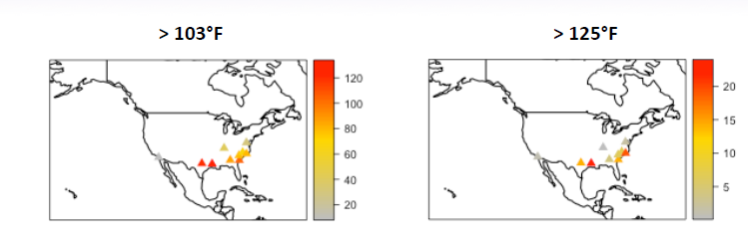

**Province of Ontario (Canada) Case Study: Towards a Harmonized Heat Health Warning System**

Health Canada and Natural Resources Canada published reports indicating the increased health risk from heat with climate change leading to the creation of Canada’s Heat Resiliency Initiative (Figure #). Heat Alert and Response Systems (HARS) are implemented at the province level. Alberta, Manitoba, and Quebec have fully implemented or supported throughout the province. British Columbia, Ontario, and New Brunswick have a range of HARS capabilities at the city level or wider.

Figure #: Number of hot days and warm nights in Canadian cities, historical data since 1961 and projected into 2100.

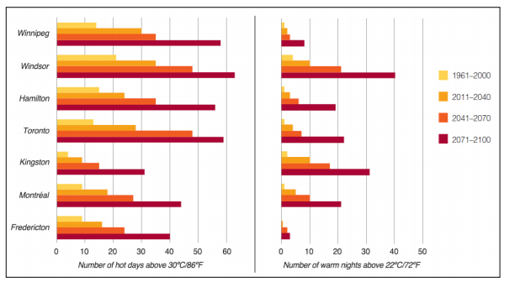

The fully implemented HARS in Quebec incorporates **research, surveillance, outreach and evaluation**. Academic research determined triggers for the warning system for the province, implemented at 4 regions based on the Tmax/Tmin over three days. Surveillance supports the response and intervention efforts with real-time health data. Quebec’s decision making tool SUPREME is used to monitor health, weather, and vulnerability indexes. SUPREME acts as a warning system for heat vulnerability as well as atmospheric pollutants including forest fires and smog and is also used to train health workers prior to heat events. Outreach through phone and email messages raises awareness in the public and helps alert the most vulnerable people. Evaluation continues to improve the alert system and preventative measures.

Ontario plans to launch a Harmonized Heat Health Warning System in 2016. The Ontario Public Health Units (PHU) fall along a spectrum of heat health preparedness and 55% have no formal heat alert protocol. One PHU (Toronto) established evidence-based triggers. Only 20% of local municipalities release heat alerts, often with different criteria from neighboring areas. The Harmonized Heat Health Warning System is a collaboration of Ontario Ministry of Health and Long-Term Care, Public Health Ontario, the Meteorological Service of Canada, and PHUs. The new system will establish consistent communication and reduce public confusion surrounding heat and health. Consistent, evidence-based approaches will be used for heat alerts with consideration to specific communities and available resources.

The alert system in Ontario is based on a **science, communication, and governance** component. The science component attempts to quantify and understand the burden of heat illness to create a heat alert protocol based on exposure of both intensity and duration of a heat event. The communication component focuses on standardized messaging and consistent terminology (e.g. warning, alert, extreme alert) using Environment Canada and Health Canada’s messages. Dissemination of information includes pre-season and pre-event awareness. At the governance level the province sets the standards for PHUs for alert triggers, alert levels, suggested activities, communication, and planning. The new system will be tested through a 2015 pilot during the Pan American and Para-Pan American Games with full implementation in 2016.

**Experience with the German Heat Health Warning System in the City of Frankfurt**

In 2003 a heat wave killed 200 people in Frankfurt, primarily elderly people half of whom were living in nursing home facilities (Figure #). In response the county of Hesse created the 2004 Heat Health Action Plan with a heat warning system. The Ministry for Social Affairs working group included healthcare professionals, representative of elderly homes, public health departments, officials of the Heimaufsicht (housing authority), and the German weather service.

Figure #: Daily maximum temperatures and daily mortality in Frankfurt, Germany from June 1 to August 31, 2003.

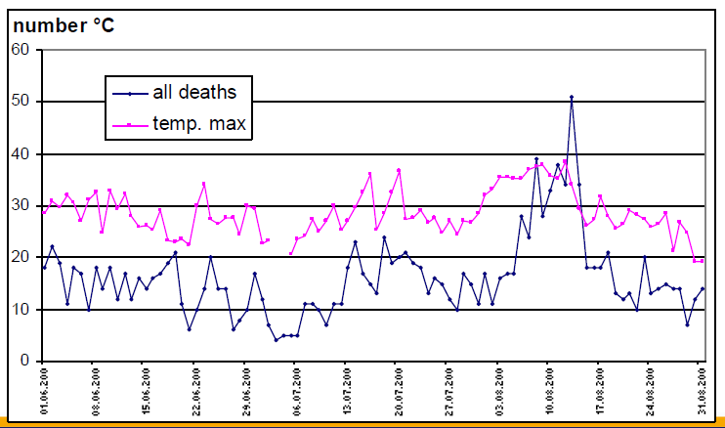

Information after the extreme heat risks is communicated to the public through radio, tv, and newspaper as well as targeted messaging through leaflets at senior meetings. Courses were developed for staff and healthcare professionals in retirement homes. In 2008, the Heat Health Warning System was launched and heat warnings by district where faxed to hospitals, nursing homes, public health offices, and other local health and government offices. The warnings utilized two levels of thermal stress combined with two levels of warnings (Table 3). Warning level one is issued when there is high thermal stress on up to three successive days. Warning level two is used when there is high thermal stress on more than three successive days or any days of extreme thermal stress. The number of days with high thermal stress is included in the warnings.

Table 3: Hesse County, Germany extreme heat warning thresholds.

|  |  |
| --- | --- |
| **Thermal Stress** | **Apparent Temperature** |
| High | >32 °C (89.6°F ) |
| Extreme | > 38 °C (100.4 °F) |

Lower mortality was seen during heat waves after the implementation of the plan, but cannot be linked conclusively to the warning system and improved communications as the heat wave periods were shorter and air pollution lower than previous years. Efforts continue to monitor and improve the the heat warning system.

**Ahmedabad Heat Action Plan case study  
*Dileep Mavalankar - Director, Indian Institute of Public Health, Gandhinagar***

Though India is often hot, heat waves have not been seen as a serious health threat until recently. In 2013, the Indian government and National Disaster Management Agency (NDMA) first recognized heat waves as natural disasters. During the 2015 heat season over 2000 deaths were reported in India indicating the serious need for prevention and response planning. The problem will intensify as by 2030, air temperature in India is predicted to increase another 2-4 degrees on average.

Heavily populated cities are at greater risk such as Ahmedabad with six million people. During a heat wave in 2010 deaths surged to over 200 in one day over the typical background level. There were over 800 excess deaths in on week and 1344 excess deaths in May overall. At one Ahemdabad hospital, the neonatal intensive care unit (NICU) was located on the top floor of the hospital under a black tar covered roof leading to increased high temperatures in newborns. The NICU was later moved to a ground floor and the roof replaced with a cool roof.

In 2011,the Public Health Foundation of India (PHFI), Indian Institute of Public Health (IIPH), and the Natural Resources Defense Council (NRDC) of the U.S. entered into a Memorandum of Understanding (MOU) with the state of Gujarat and city of Ahmedabad. The group formalized collaboration for heat research and hosted the first scientific workshop on climate change and heat-health in 2011. The workshop gathered scientists, stakeholders, and partners. Preliminary studies assessed the situation in Ahmedabad by focusing on various vulnerable groups.

A heat vulnerability survey was conducted in the slum community including 300 households and 2,650 individuals. Slum communities are vulnerable to effects of heat, but also largely unaware of the dangers. A Construction Worker Vulnerability Survey (HOTHAPS) of 319 workers from five sites concluded that all construction workers work in extreme heat conditions above the American Conference of Governmental Industrial Hygienists (ACGIH) standards. During the summer 10% of workers were hospitalized at least once. A vulnerability survey of various occupational groups showed a high prevalence of heat related illness, dehydration, exhaustion, headache, thirst, and body cramps. Workers showed increased core body temperature during hot days and were often working in temperatures greater than ACGIH standards. In all surveys awareness and knowledge of heat health impacts was low. An analysis of urban heat island effects in Ahmedabad showed areas with vegetation were 2°C. A heat contour map is planning to show areas of vulnerability on a small scale.

Building on the vulnerability assessments an Ahmedabad Heat Action Plan was created in 2013, the first heat action plan in South Asia. The plan was a collaborative effort by the IIPHG-NRDC partnership and the local city and state partners. A series of stakeholder meetings were held to create local key actions. The main activities of the plan include **analysis, training, and awareness**. Data from the 2021 research was used to create localized plans and set temperature cut offs for warnings. Training of medical was implemented specific to management of heat illness. Public awareness utilizes posters, fliers, billboards, media engagement, and direct outreach. The team made an effort to learn from previous international experiences to align the warning system with global best practices. With the help of the CFAN center at Georgia Tech helped develop a 7-day forecast for the heat early warning system. The temperature thresholds were decided based on the conditions during increased mortality seen in previous years (Table 4).

Table 4: Ahmedabad heat early warning system

|  |  |  |
| --- | --- | --- |
| **Condition** | **Temperature Thresholds** | **Alert Level** |
| No Alert (cool day) | <41.0 | White |
| Hot Day | 41.0 - 42.9 | Yellow |
| Heat Alert Day | 43.0 - 44.9 | Orange |
| Extreme Heat Alert Day | ≥45.0 | Red |

Determining the effectiveness of the heat action plan is difficult as the data for heat wave mortalities is not available for many past heat waves. The 2010 Ahmedabad has to serve as the basis for measuring an impact of the plan. Compared to 2010 the heat induced mortality and heat stroke cases was reduced by 76% (Figure #). Plans continue to extend the warning system and to monitor the progress and evaluate with rigorous scientific methods. Currently Nagpur and seven other cities in central India are working to develop heat alert plans as well as three states. There is also discussion of a national system based on the Ahmedabad program.

Figure #: Comparison of temperature, heat stroke cases, and deaths in 2010 and 2014 after the heat warning plan was implemented.

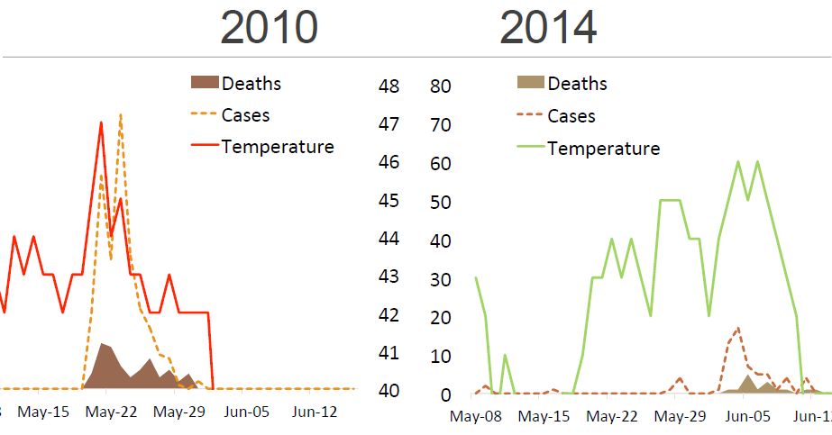

# 

# 

# **3. Heat Exposure Parameters and Health Outcomes**

## Christina Koppe-Schaller (DWD)

### Context

Given previous discussions on climate and weather forecasting capabilities, and on public health needs to manage heat risk, this session explored the indicators that are currently used for heat health early warning and why they are used - including a consideration of how needs may differ based on demographics and geography, suggesting a need for variable prediction capabilities.

*Moderator: Juli Trtanj - NOAA One Health and Integrated Climate Research Lead, NOAA Climate Program Office*

* CDC National Environmental Public Health Tracking Network *Shubhayu Saha - Health Scientist, Climate and Health Program, National Center for Env. Health, CDC*
* Sub-Heat Wave Health Effects  
  *Thomas Matte - Assistant Commissioner, New York City Department of Health and Mental Hygiene*
* Indices for Heat Health Warning Systems – General Considerations  
  *Christina Koppe - Deutscher Wetterdienst, Germany*
* Heat Waves and Public Health: A European Perspective

*Jan C. Semenza - European Centre for Disease Prevention and Control*

* Making Heat Forecasts Public-Health Relevant on Climate Time Scales: Lessons Learned from the Trenches  
  *Kris Ebi - Professor, Departments of Global Health and Occupational and Environmental Health Sciences, University of Washington*

Given the range of population vulnerability to extreme heat, what physical science data and predictions are required to achieve the desired health outcomes? What parameters should be used, under which conditions, and for which population types? What are the gaps and what are the highest priority areas for the research communities represented here to focus on?   
(Incl. forecasts, observation and surveillance, raw data and prepared information products.)

### Overview

The thresholds for health outcomes due to hot weather differ from population to population due to adaptation and acclimatization to climatic conditions and within populations due to individual sensitivity and risk factors such as age, health and social status as well as due to individual exposure patterns. Heat waves can differ by location in intensity, length, and number (Figure xx). Also, different health outcomes have different thresholds and optimal heat metrics. Adding to the complexity, the relationship between heat and health is a continuum. The prevalence of heat illness differs regionally (Figure XX) and thresholds for warnings have to be determined not only based on the mere impact of heat on health but also including other considerations such as the frequency of warning situations and cost-benefit considerations on the intervention measures triggered by the warnings. Given the potential for differences it is not possible to establish one definition or trigger of dangerous heat situations that fits all possible applications and locations, but different definitions for triggering heat warnings in adjacent communities can lead to boundary problems.

Figure xx: Heat wave characteristics in 43 individual communities (1987–2005). Each horizontal line represents one community, and the length of each line indicates the range of each heat wave characteristic in that community. (A) Intensity of each individual heat wave within a community (tick marks within blue bars). (B) Number of heat waves according to duration (shading) by community. By definition, all heat waves lasted ≥ 2 days. (C) Heat wave timing in season by community (tick marks, individual heat waves). (Anderson and Bell, 2011)

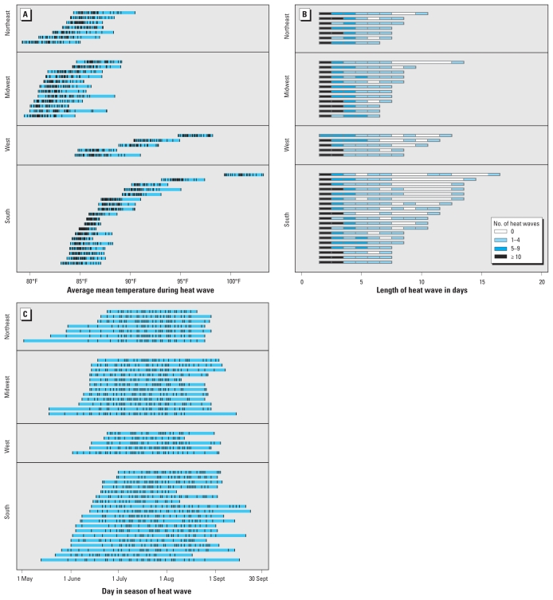

Figure xx: Results from the random effect meta-analysis of odds ratios of hyperthermia-related ED visit associated with maximum temperature grouped by latitude categories (Saha et al. 2015).

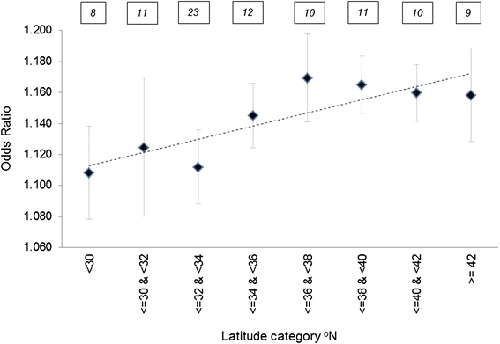

The established heat-health relationships are influenced by a lot of confounding factors. Heat or climate is not the only trigger for morbidity and mortality. Especially in small populations these confounding effects are often stronger than the effect of heat. Often the different indices are highly correlated, so that differences in the heat-health relationships between the indices are often not significant. In small communities it can be hard to establish a significant relationship between heat and health, due to many other factors that influence daily death or hospital admission rates. Most indices for heat-exposure used to describe relationships with health outcomes are calculated for outdoor conditions. However, a large fraction of heat-related deaths occur to people that stay most of the time indoors.

Theoretically it would be possible to calculate an individual heat load using a complete heat budget model of the human body if all parameters describing the body's’ heat production, heat exchange with the environment, and individual sensitivity were known. Such calculations are quite complex and are not possible on a population level. The different indices used for heat warnings are therefore always a simplification of the real heat load that single individuals experience. Indices for heat warnings range from simple approaches using for example a threshold of maximum air temperature to heat budget models.

**Table x: Table of different groups of indices used for heat warnings and their advantages (+) and disadvantages (-)**

|  |  |  |  |  |
| --- | --- | --- | --- | --- |
|  | **Single & multi-parameter indices** | **Simplified biometeorological indices** | **Air mass based approach** | **Heat budget approaches** |
| **example** | Tmax or Tmax and Tmin | Heat Index | Spatial synoptic classification SSC | Perceived temperature PT |
| **Reliability** | | | | |
| **Forecast skill, lead time** | + | - | - | - |
| **Health relevance** | - | + | + | + |
| **Easy to handle** | | | | |
| **No complicated modelling** | + | + | - | - |
| **Easy to implement** | + | + | - | - |
| **Low input data requirements** | + | - | - | - |
| **Universal** | - | - | - | + |

There is a balance of advantages and disadvantages between simple and complex approaches to heat indices (Table X). While simple approaches have the advantage that the meteorological input parameters have relatively good forecasts skills also on longer time scales, the disadvantage of these approaches is that they do not have an inherent relevance for human health. This has the consequence that heat-health relationships and warning thresholds have to be established for each location. But not for all locations sufficient long time series of health data are available. On the other hand complex indices based on heat budget models have an inherent health relevance. However they require meteorological input parameters such as dew point temperature that have a much lower forecast skill than air temperature. In addition, to calculate a heat budget model is not easy to implement in the daily computing routine.

Not only the index and the threshold used for triggering a warning are important but also other factors such as the duration of the heat wave and, in some cases, also the timing of the event. Studies show that the longer the duration of the heat-wave the higher is its’ impact on mortality. Heat-waves early in the summer are in some studies related to a higher mortality rate than heatwaves later in the year.

As there is no perfect heat exposure parameter that fits all possible applications for heat warnings, the pros and cons of the different approaches combined with the local requirements, computing capacity and triggered intervention measures should be taken into consideration when setting up a heat warning system. The ideal heat health warning system would have reliable forecasts and health relevance, uncomplicated modeling and implementation, and effective communication with sufficient lead time.

Interventions as response to heat warnings can be short-term such as for example opening cooling centers, formal buddy systems and the provision of water and power supply. Crucial for short-term interventions is a well-working communication system, with clear messages to the target population. However, it has been shown that only 50% of the people who knew about a current warning changed their behavior. The short-term interventions should be supplemented by long-term strategies to decrease heat-exposure (e.g. urban planning) or to decrease the sensitivity of the populations (e.g. minimizing risk factors such as obesity).

# 

# 

# **4. Developing a National Integrated Heat Health Early Warning System**

## Hunter Jones (NOAA/OAR)

## Content

<https://docs.google.com/a/noaa.gov/document/d/1XasA6eTcHiLAZz9fxQGpKo3tdAak36xQBb7QuRRW-2o/edit?usp=sharing>

### Context

This session explored the heat-health parameters and methods currently being employed in various Heat Health Early Warning Systems around the world and their applicability to longer (climate) timescales.  
*Moderator: Wayne Higgins - Director, NOAA Climate Program Office*

* National Weather Service Perspective  
  *Andrea Bair - Physical Scientist, NWS Western Region, Climate Services Division*
* Canada’s Heat Alert and Response Systems  
  *Sharon Jeffers - Acting Service Chief, Central Region, Meteorological Service of Canada Environment Canada*
* Extreme Heat Response in South Australia  
  *John Nairn - Bureau of Meteorology, South Australia, Australia*
* India’s Experience with Extreme Heat  
  *Brahm P. Yadav - Head, National Weather Forecasting Center, India Meteorological Department*
* Heatwaves and Health: WMO/WHO Guidance on Warning-System Development  
  *Glenn McGregor - Professor of Climatology and Principal of Ustinov College, Department of Geography, Durham University, United Kingdom*

How is the transition from weather to climate time scales being accomplished? How are health data being integrated? What improvements in prediction capability are needed at climate timescales and decision relevant spatial scales to predict public health outcomes from extreme heat events? What are the lessons learned and common challenges and opportunities for implementing a national integrated system at spatial scales relevant to decision making?

## 

**Introduction**

Extreme heat is a global problem. It affects concentrated urban centers and sprawling rural areas, developed and developing countries, and tropical and temperate climes. However, the experience of extreme heat varies dramatically - and the heterogeneity of culture and climate means that what is normal or tolerable to some may be oppressive and dangerous to others. These differences in experience have resulted in a variety of approaches to managing the risk of extreme heat, and this workshop sampled many of these approaches in order to understand how to draw on commonalities to develop nationally consistent heat health systems while at the same time allowing for regional and local specificity.

Session 4 of the workshop explored heat health systems in several countries (indicated below) with differing circumstances in order to understand what variables should be customized based on socioeconomic and geographic factors, and what critical success factors existed in all countries. The session sought to understand how health and meteorological data is integrated, and which spatial and temporal scales are important in addressing extreme heat.

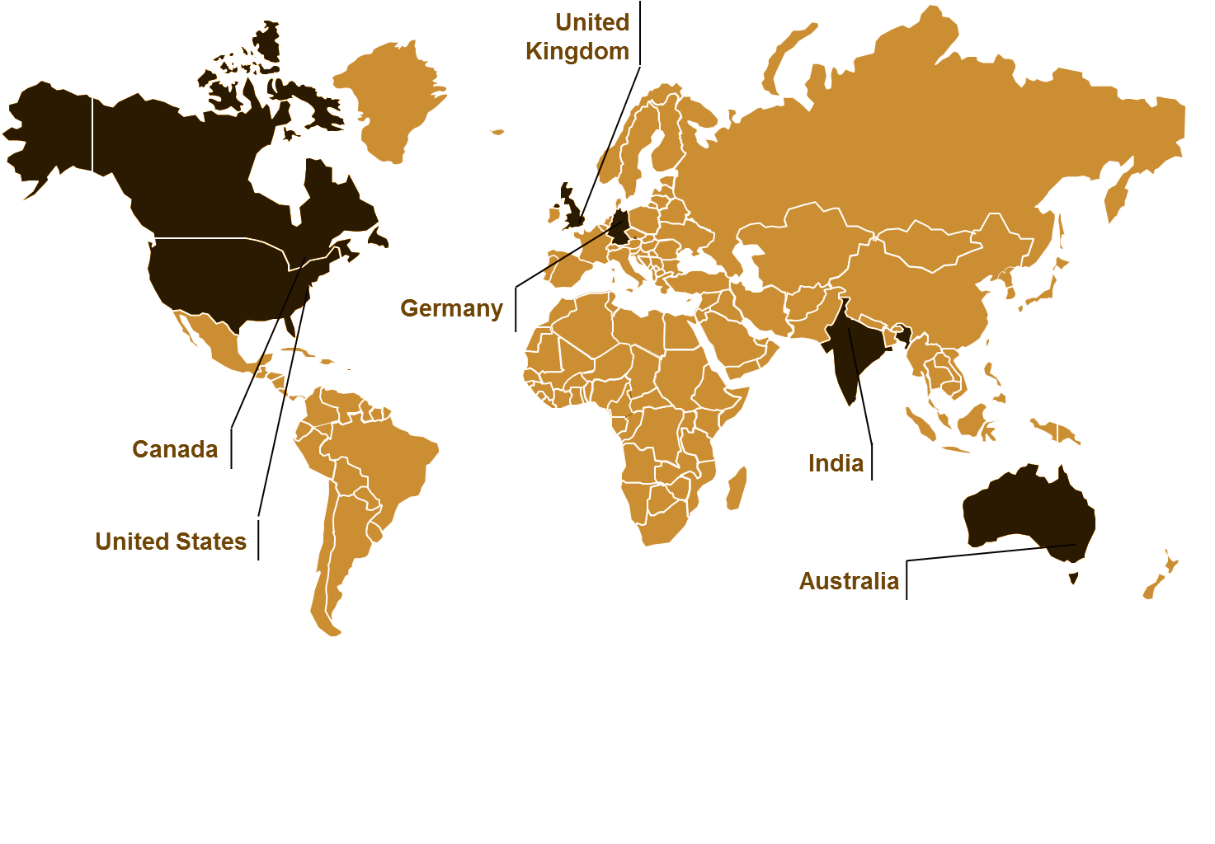  
***Figure 1.*** *Representatives from the countries highlighted above were present at the workshop to detail their country’s experience with heat health early warning systems.*

The countries above all experience different climatological norms (Figure 2) which causes them to have a different tolerance to high temperatures and humidity.

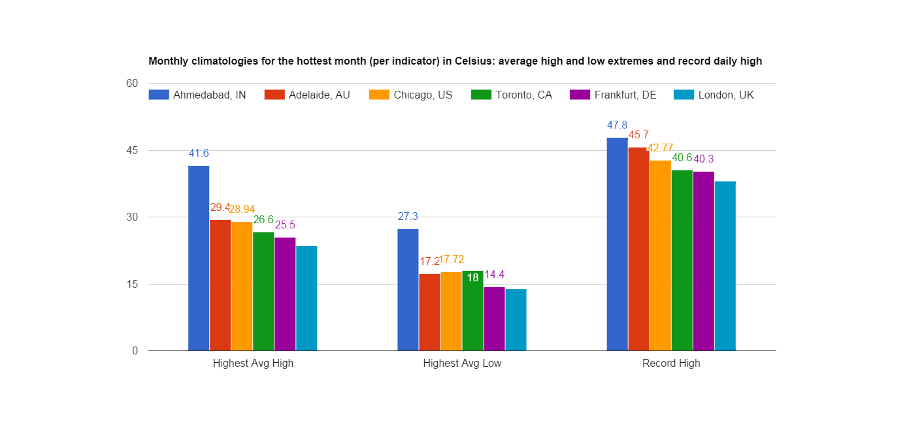

***Figure 2.*** *Climatologies for sampled cities / countries *add projections to this chart for 2050? Do we have better information on global heat waves rather than just extreme heat? This could be average number of heat waves experienced (by some consistent metric) or (morbidly) the incidence of death due to hyperthermia.*

## Germany

**Reviewers:** *Paul Becker (Deutscher Wetterdienst); Ursel Heudorf (Department of Medical Services and Hygiene, Frankfurt); Christina Koppe (Deutscher Wetterdienst)*

### Focusing Event

Following an exceptionally lethal heat wave in 2003 (which broke records at 40.2C in August and saw excess heat-related mortality of 7,000 people in Germany), the German government began to develop a Heat Health Warning System (HHWS) in line with a new philosophy of seamless prediction along the weather-climate continuum. The goal was to provide not only warnings, but also pre-information intended to reduce mortality and morbidity due to extreme heat. The German HHWS became operational in 2005, and issues warnings at the district level (of which there are 402, 27% of which are considered urban). Subsequent heat waves in 2006 and 2008 have allowed them to improve and test their HHWS. Though attribution is difficult, it is believed that the system has reduced mortality. Germany was hit by another heat wave just weeks prior to this workshop in July 2015 that broke the 2003 heat record by one tenth of a degree, however, mortality was again observed to be blunted due to early warning and better communication and preparation.

### The Heat Early Warning System

The German HHWS is based on a Perceived Temperature (PT) index, which was developed by DWD, and which implements a heat budget model. A standard human model, called Klima Michel (of average height and weight, aged 35 and male) is used to model heat exchange under a set of meteorological conditions including air temperature, wind velocity, humidity, and insolation. PT is a function of these parameters and Klima Michel’s absorption and dissipation of heat.

Klima Michel is not seasonally static, but rather is dressed with seasonally appropriate attire and modeled to spend time outside (Jendritzky et al. 2000). As such, the heat budget is computed using an assumption of lighter clothing in summer, and heavier clothing in winter (including a necktie). Indoor exposure is also modeled to compute the nocturnal thermal load, and together the indoor and outdoor thermal load inform DWD warnings. A balance is struck in simplifying the heat budget using a comfort equation derived by Fanger (1970), which omits sweating and core temperature, for example. Moreover, meteorological observations are also simplified through derivation from commonly observed values - 1m high wind is calculated from 10m high observations, and radiation exposure is calculated using synoptic scale cloud cover.

Extreme heat warnings operate on the scale of 1-2 days, forecasts extend to 6 days within Germany, and to 10 days within Europe via the DWD produced EuroHeat product. A survey of assessment user needs conducted within Germany determined that 75% of respondents were interested in weather-scale heat information, 63% were interested in climate-scale information, and 25% were interested in monthly-seasonal scale information. Participants were not asked about decadal-scale information needs.

Warnings are issued when the PT exceeds 38°C (extreme heat load) or when PT exceeds 32°C for two consecutive days and indoor temperatures at night exceed 24°C. Upon triggering a warning, communication via smartphone apps, web sites, newsletters, and other electronic means is conducted with the general public, the media, nursing homes, and health authorities.

Heat pre-information, or forecasts, are prepared according to the German Engineering Association’s VDI thermal stress indicator levels (none, low, moderate, strong, extreme) and the forecast perceived temperature. Beyond one week, DWD does not believe PT forecasts are reliable, and as such the projection method used is heat wave probability via the EuroHeat project.

Euroheat is a probabilistic ensemble prediction system that uses 50 ensemble forecasts from ECMWF with perturbed initial conditions to predict the temperature at 2m. When greater than 30% of models predict heat wave temperatures (not sure what the threshold is)

Germany’s HHWS is still adapting as its use invites new possibilities. There is a lot of interest in city-specific heat projections, and downscaled data has become very popular. There is also a desire to combine heat and socioeconomic information to compute the distribution of risk in conjunction with heat load.

## India

**Reviewers:** *Dileep Mavalankar - Director, Indian Institute of Public Health, Gandhinagar; Brahm P. Yadav - Head, National Weather Forecasting Center, India Meteorological Department*

### Focusing Event

Ahmedabad, the largest city of India’s Gujarat state and home to over 6 million people, found it's focusing event in 2010, when a heat wave with temperatures reaching 46.8 °C (116 °F) swept across the subcontinent and resulted in 1,344 registered deaths in the city (Azhar et al., 2014). A newly formed international partnership between NRDC and the Public Health Foundation of India seized on the focusing event and the interest of the Ahmedabad Municipal Corporation (AMC) in extreme heat by developing a Heat Action Plan (HAP) in partnership with several other local and international collaborators from government, academia, and the non-profit sectors (Knowlton et al., 2014). When it was completed in 2013, the plan described a vision for resilience to extreme heat that included an early warning system, public awareness and outreach, capacity building, and mitigation and adaptation measures.

### The Heat Action Plan

Ahmedabad’s HAP was the first in South Asia, and represents an important case study for the implementation of regionally appropriate heat health systems as it was bolstered by several data gathering activities during its formation. A survey of Indians living in slums revealed that such a community is highly vulnerable to extreme heat - especially newborns which are brought home to the slums just days after being born. A survey of construction workers found that 10% were hospitalized at least once annually for heat-related maladies. Heat island studies determined that vegetation could reduce the air temperature by several degrees Celsius. As a result, the plan underscores outreach and education strategies for exceptionally vulnerable communities, and encourages practices such as leaving public gardens open and opening cooling centers in the afternoon when temperatures are highest.

One of the challenges to developing the HAP was mortality and morbidity data collection. While all-cause mortality data was readily available in the city proper, collecting this data for the rural community - where deaths are not all captured with via a formal process - is challenging.

The Ahmedabad experience developing a HAP is now being replicated throughout India. Nagpur and seven other cities in central India as well as Odisha state in the East, and Hyderabad in Telangana State, are currently developing plans of their own. At the same time, the Ahmedabad HAP and early warning thresholds are being refined as information continues to be collected. One area identified for additional investigation is the sensitivity to nighttime minimum temperature.

### Heat Early Warning System

The Indian Ministry of Earth Sciences (MoES), which contains the Indian Meteorological Department (IMD), National Centre for Medium Range Weather Forecasting, and the Indian Institute of Tropical Meteorology as well as other centers, performs seasonal, monthly, and extended probabilistic and ensemble forecasts - including a 7-day short and mid-range forecasts. The IMD provides weather forecasts and warnings, including heat warnings, but currently can only skillfully produce heat forecasts out to three days. IMD uses min and max T exceedances from climatology to classify heat waves and extreme heat waves.

The HAP complements this warning from the IMD with a 7 day hybrid dynamical-statistical temperature forecast system developed at Georgia Tech, one of the HAP partners, to classify the upcoming 7 days as “safe”, “hot”, “very hot”, or “extremely hot” along with assigned likelihood values of “high” (75%) “medium” (50-75%) and “low” (<50%).

Heatwaves in India can persist for periods up to two weeks, and the number of days classified as being part of a heatwave has increased as well as the average max temperature observed during a heatwave.

## United States

**Reviewers:** *Andrea Bair - Physical Scientist, NWS Western Region, Climate Services Division; Michelle D. Hawkins - Executive Officer (Acting) Analyze, Forecast, and Support Office, NOAA National Weather Service*

### Focusing Event

The United States has had many heat waves over the past several decades, and cities such as Chicago (in 1995) and Philadelphia (in 1993) suffered high mortality as a result of these events. These cities have learned from the past and implemented sophisticated forecasting and response approaches that have likely reduced mortality, but a great heterogeneity of approaches exists across the United States, and a thorough analysis of the effectiveness of many of the approaches has not been conducted - nor has formal information sharing at the national scale been coordinated. In some regions, a synoptic air mass classification system is used to identify oppressive weather patterns, while in others simpler temperature, humidity, or heat indices are used.

Philadelphia was the first city to implement a synoptic classification system (Kalkstein et al., 1996), and has paid much closer attention to the outcomes of its heat early warning system in the recent past (Ebi et al., 2004). Chicago also implemented a sophisticated emergency management approach through their Office Emergency Management Communication (OEMC) by channeling their response through their operations center, which can be activated rapidly in case of a variety of emergencies - including heat extremes. However, a national, integrated approach is still needed improve management of risk and response to extreme heat.

### Heat Early Warning System

The National Weather Service (NWS), based in Washington D.C., produces many heat-related forecast products that are made available to the regional Weather Forecast Offices (WFO) around the United States. Though NWS does set policies that apply to WFOs, and supports many of their data and modeling needs, it is the Meteorologist In-Charge (MIC) at each WFO who decides which approach to use when assessing heat risk, and it is the MIC who determines when to issue heat watches, advisories, and warnings. Some WFOs have collaborated with local health agencies to determine regional sensitivities to heat, but many have not. As a result, one or more of the aforementioned approaches may be used to inform heat early warning in one WFO region, while another may be in use in an adjacent region.

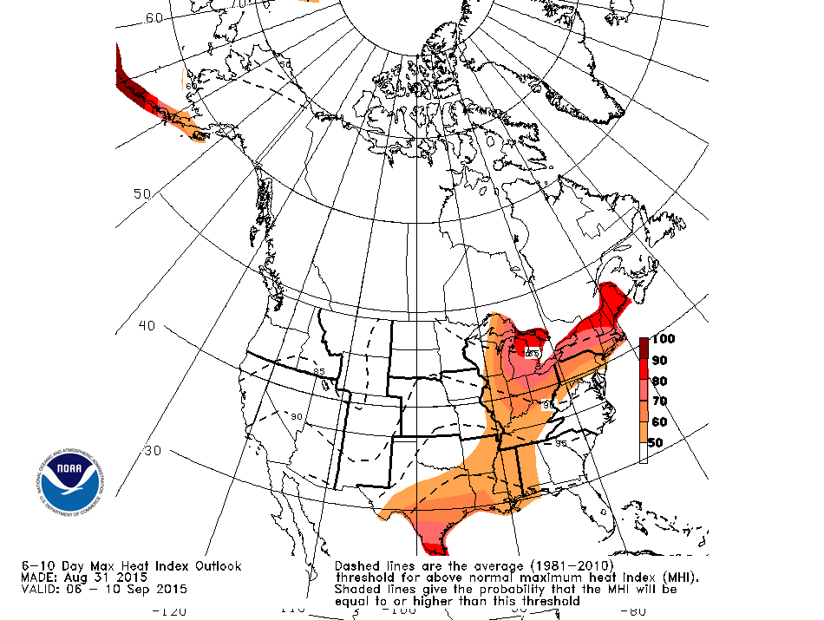

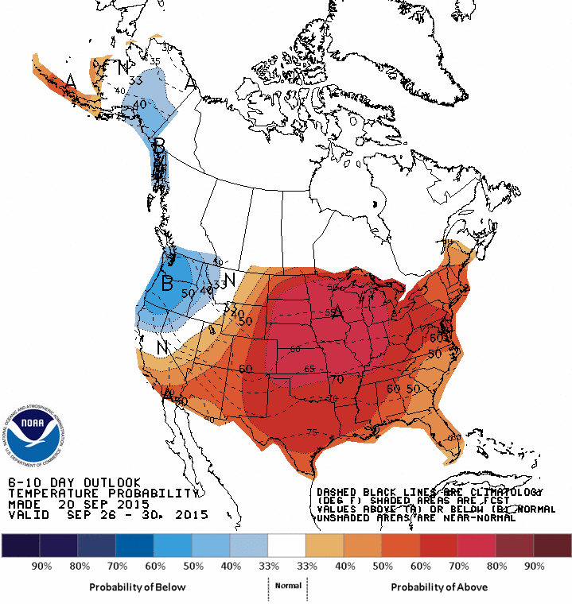

A seventy-two hour lead time is typical for a heat watch across the WFOs, and a standard product available through the Climate Prediction Center at the national level predicts the heat index out 6-10 days in addition to 6-10 day temperature and precipitation outlooks. Experimental products that predict out to two weeks are also being developed.

In addition to heat forecasting for health concerns, some NWS regions are focused on broader-use heat forecasts that can be used for decisions related to infrastructure, power, agriculture, and livestock. A new Heat Impact Level product is being developed in California and tested that puts heat predictions in a climatological context by categorizing heat in terms of its potential to impact normal functioning of these industries compared to typical levels. Such an approach takes into consideration seasonal variation, acclimatization, and high resolution information from urban monitoring stations.

## Canada

**Reviewers:** *Sharon Jeffers - Acting Service Chief, Central Region, Meteorological Service of Canada Environment Canada*

### Focusing Event

Canada has been able to generate support for heat early warning independent of a specific focusing event. It is well known that northern latitudes are changing much faster than lower latitudes as a result of external climate forcing, and as such, Canada has taken a proactive approach to implementing Heat Early Response Systems (HARS). There are many systems currently in place, and there are many pilots underway to develop these systems for other regions and cities. Federal meteorology and health bureaus are involved in the development in these systems, but they are controlled locally due to varying requirements across the country.

### Heat Early Warning System

Due to the gradual development of these systems across Canada, there is also an effort underway to harmonize the HARS. The HARS in most provinces use some combination of MaxT, MinT, or Humidex, and early warning needs vary based on the intensity of response. Quebec leans toward longer lead times because their response plan includes community health center training, while other provinces only require shorter lead times. Just as in the United States, regional differences in approach to heat early warning sometimes lead to abutting regions employing different thresholds - causing one to issue an alert when another may not, which can be confusing to residents living near the boundaries.

The Canadian HARS place a premium on integrated health information via syndromic surveillance and GIS technology (using platforms such as WISDOM and SUPRÊME), and also on integrating socioeconomic indicators to understand risk to extreme heat. The Quebec and Ontario GIS systems include consideration of heat island effect, social deprivation, and other demographic variables. A strong interest in urban-scale forecasts and predictions was noted, and multi-hazard forecasts that include air quality are desired in Canada - as heat and air quality can trigger comorbid conditions - and the Canadian west has been experiencing an exceptional forest fire and smoke year.



## Australia

**Reviewers:** *John Nairn - Bureau of Meteorology, South Australia,*

### Focusing Event

Australia was besieged by an extreme heat wave in 2009 that captured the attention of the public and the public sector. At least 374 deaths in Victoria, and 500 deaths in Adelaide and Melbourne combined were determined to be linked to the extreme heat. The extreme heat was also the cause of bushfires, which come along with comorbid impacts on human health such as exacerbated asthmatic issues. This effect is not unique to 2009 or to Australia. A similar set of circumstances emerged in 2013 in Australia, and at present in the United States (2015) extreme heat outbreaks and wildfires have been experienced in the western United States.

### Heat Early Warning System

One approach to quantifying extreme heat in Australia is the Excessive Heat Factor (EHF), developed by John Nairn. It takes into consideration the 3 day forecast departure from the climatological maximum temperature norm as well an acclimatization factor based on the temperature over the past 30 days. If the temperature forecast is exceptionally high compared to climatological norms then the EHF will be quite high - unless this has been the case for an extended period of time, at which point the acclimatization factor will kick in and reduce the EHF under the assumption that Australians will have adjusted to the extremes (Nairn and Fawcett, 2014).

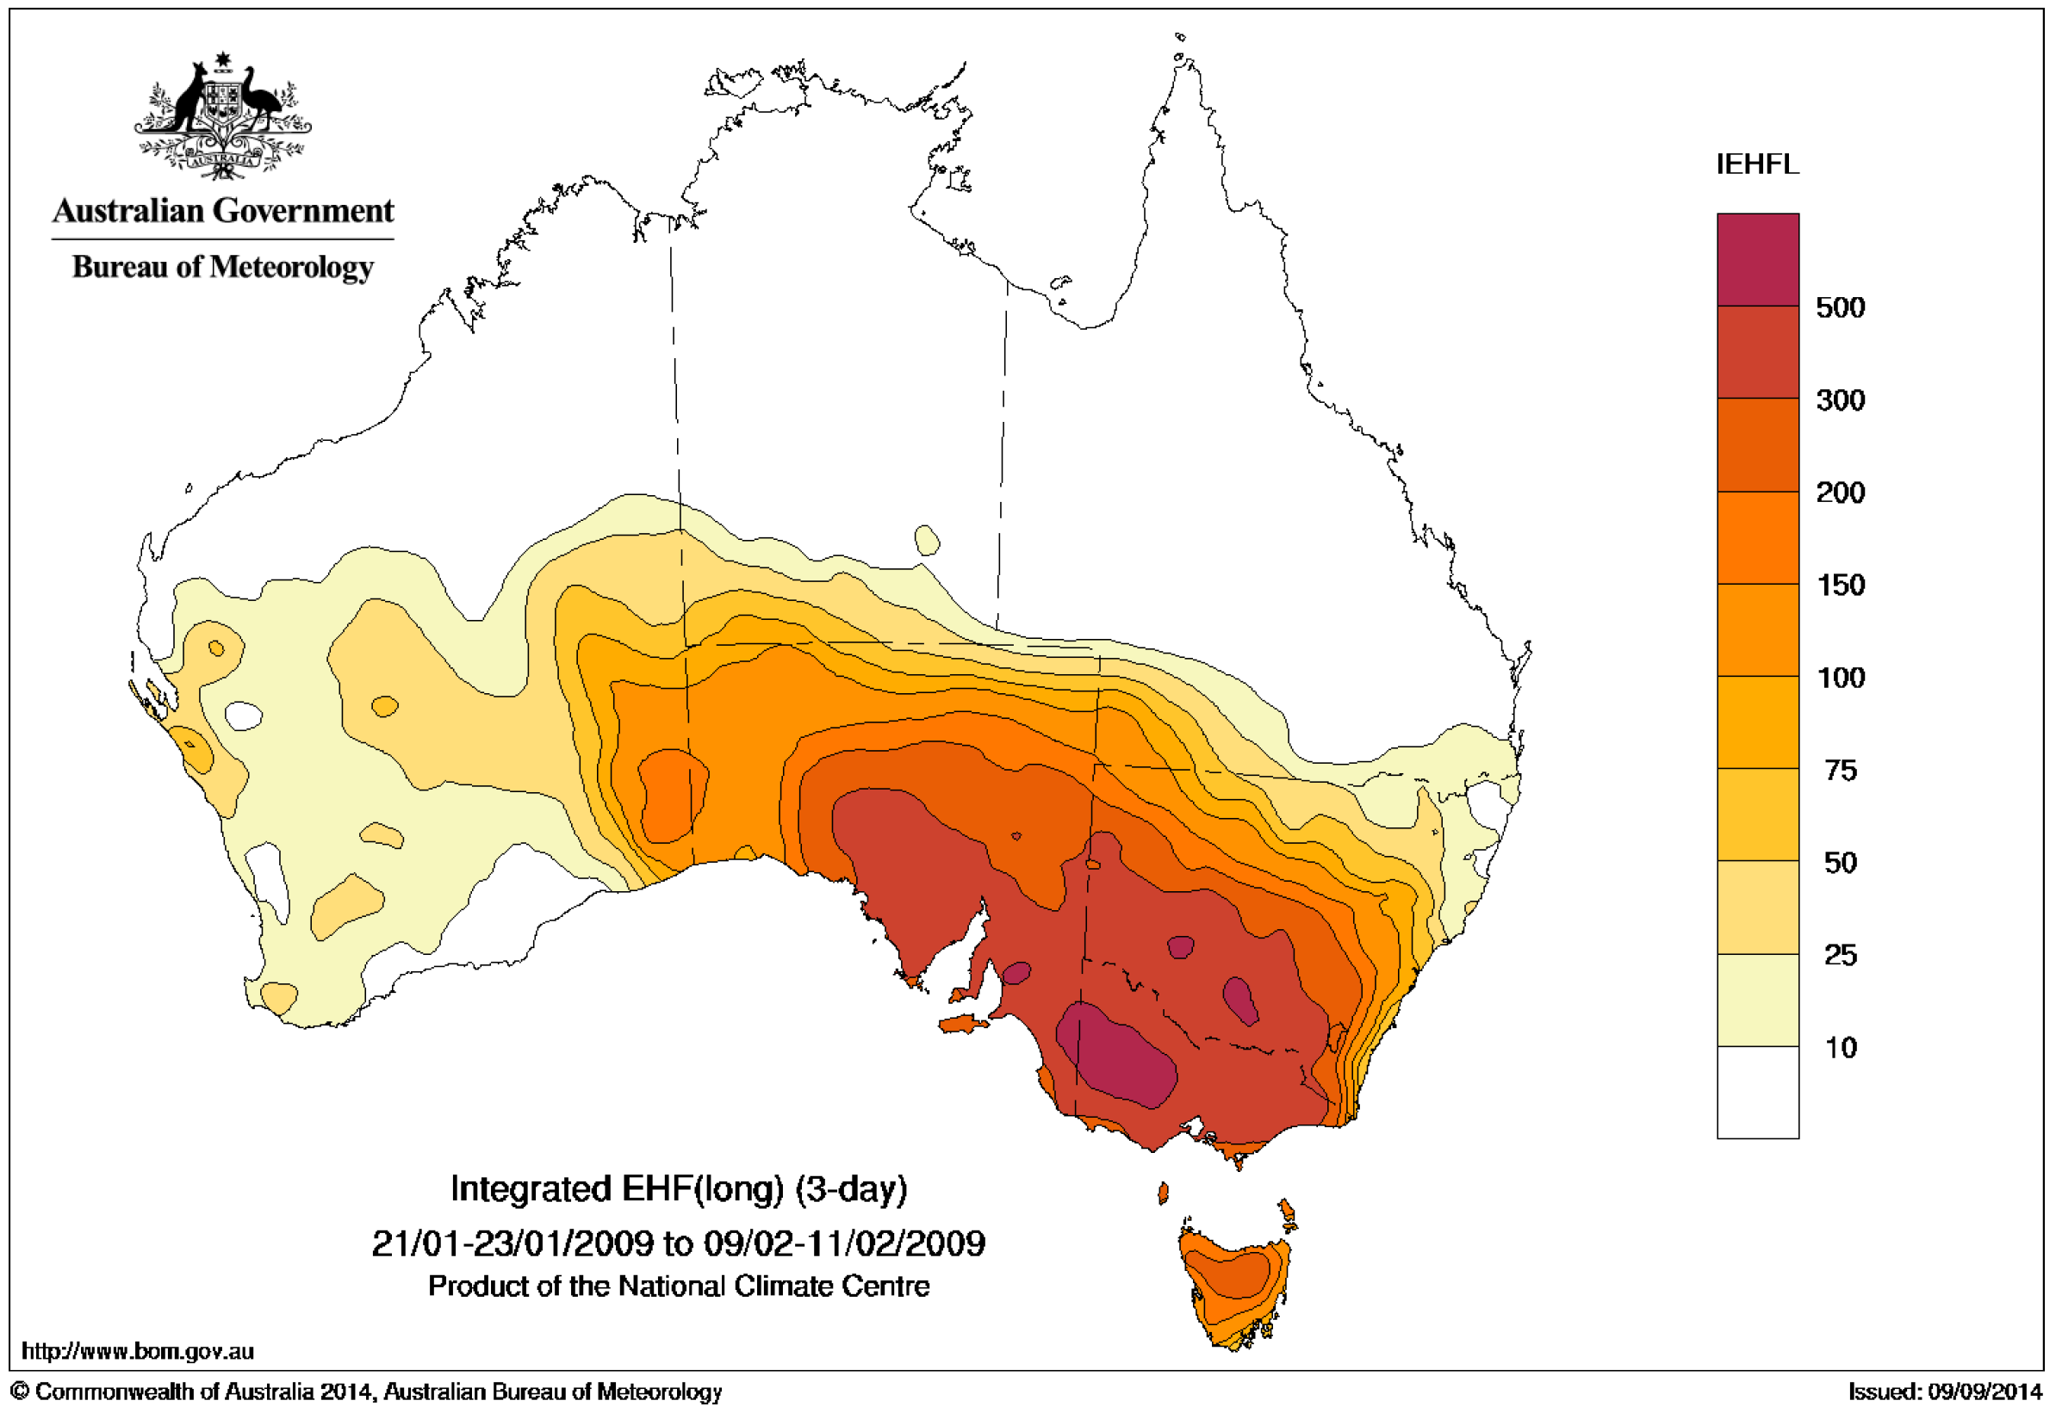

The current approach within the Bureau of Meteorology (BOM) is a short-term heat forecast based on numerical weather prediction, but there is an effort to seamlessly extend this activity to seasonal predictions. This activity would occur under a ready-set-go construct where the ‘ready’ period is a less certain, granular seasonal forecast that portends an extreme heat event and allows for preparatory activities that require a long lead time. The ‘set’ stage is based on mid-range forecasting and is essentially a warning state, and the ‘go’ stage is the weather-scale alert that extreme heat is imminent.

The seamless prediction broken into phases is useful because it has been determined that 85% of heat waves in australia are low-intensity, so they may not require as strong a response as the much less likely high-intensity heat waves. Thus the increasing certainty that emerges as time passes allows for an adjusted response. Additional findings in Australia include the importance of layman explanations of the difference between intensity and severity of heat waves and the importance of coordinating heat criteria for warnings across all responding agencies.

## Global - WHO/WMO

**Reviewers:** *Glenn McGregor - Professor of Climatology and Principal of Ustinov College, Department of Geography, Durham University, United Kingdom*

Extreme heat is a prime example of a climate hazard requiring a risk management approach, such as is the focus of the Global Framework for Climate Services (GFCS). In recognizing the global threat of extreme heat, the World Meteorological Organization and World Health Organization jointly prepared a guidance document on heatwaves and health to help countries around the world prepare for extreme heat. Increasing urbanization and exposure to extremes in addition to variable national capacity to address such issues suggests that international guidance on climate risk management, and extreme heat more specifically, is greatly needed.

The WMO/WHO publication “Heatwaves and Health: Guidance on Warning-System Development” brings together the varied national and sub-national experiences on HHWS globally into a single reference volume. The publication includes background on the epidemiology and physiology of heat stress, heat health parameters, guidance on developing early warning systems, communication, intervention, planning and evaluation of heat health information systems. National meteorological services and health agencies, which must work closely together to address the issue, can use the publication to support the development of these systems.

A key need identified within this session is the local threshold for a community where mortality begins to increase. However, heat is a complex phenomenon and there is no universal definition of what extreme heat is or where the threshold should be. Moreover, stationarity is not a legitimate assumption, so the threshold will need to be adaptive as conditions change. Additional highlights from this session include acknowledgement of the need for a comprehensive ‘heat action plan’ of which the early warning system is just one component, and a lead agency that will be accountable for heat as a hazard.

|  |  |  |  |  |  |  |
| --- | --- | --- | --- | --- | --- | --- |
|  | **USA** | **Canada** | **Germany** | **UK** | **India** | **Australia** |
| **System Type** | Federated heterogeneous - including synoptic, heat index, and temperature indicators | Adaptive based on air temp, Humidex, air pollution & mortality | Heat budget Perceived Temperature (PT) |  |  |  |
| **Alerting Agency**  **Type** | Weather & Climate | Public Health | Weather & Climate | Public Health | Municipal Government | Public Health or Emergency Services |
| **Heat Action Plan** | No national plan, states and cities have plans |  |  |  |  | Sub-plans required by each state |

Table x. The different approaches to heat health by the featured countries are summarized in the table above.

## 5. Stakeholder Engagement, Risk Perception, and Communication

## Vankita Brown (NOAA/NWS)

### Context

How is heat health information communicated, including risk characterization, roles and responsibilities, and varied media and messaging tool strategies.

*Moderator: Cheryl Nelson, StormCenter Communications Consultant/Broadcast Meteorologist*

* WHO Heat Action Plan  
  *James Creswick - Technical Officer, WHO Regional Office for Europe*
* Climate Resilience Toolkit and Climate Data Initiative  
  *Ned Gardiner - Executive Producer of Video & Sr. Visualizer, NOAA CPO*
* SIMMER Project - Modeling of Extreme Heat Risk  
  *Olga Wilhelmi - NCAR Research Applications Laboratory*

Assessment of current communication efforts and outcomes, as well as communication needs and gaps. How effective are existing communication plans and tools, who is using them, and how do we make them more effective? How can we best target most vulnerable groups? Is there a common communication tool or platform, and if not, should there be?

### Overview

### World Health Organization Heat Action Plan

The WMO provides guidance to countries on developing heat health action plans. Eighteen out of 51 have developed heat health action plans, with Croatia, France, Macedonia, having the most comprehensive plans.

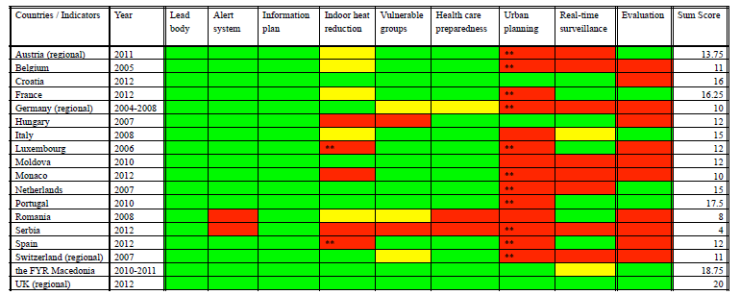

The planning includes eight core elements:

* Define the governance of the plan including who is the lead agency, and what are the roles and responsibilities of agents involved.
* Alert system, where by thresholds are determined for implementing action and communicating risk.
* Determine what information is communicated to whom and when.
* Advice on short and long term strategies for reducing indoor heat exposure.
* Identifying and locating the vulnerable groups.
* Preparedness of the health and social care systems by proving training and planning.
* Long term urban planning that involves addressing building design, energy and transport policies to reduce heat exposure.
* Real-time surveillance and monitoring evaluation.

### The Climate Resilience Toolkit and Climate Data Initiative

The U.S. Climate Resilience Toolkit and Climate Data Initiative were established as a part of the White House’s Climate Action Plan. The goal of the Toolkit is to take new knowledge and show application in decision making with regard to assessing risk and building community resilience in light of climate impacts. Using a case study approach, the Toolkit, features examples of where people have taken climate information, applied it, and demonstrated new capability. The Toolkit provides a five step outline that leads participants from assessment to implementation. It begins with identifying the problem, examining vulnerabilities, investigate options, examining risk and cost of the options, and finally implementing action.

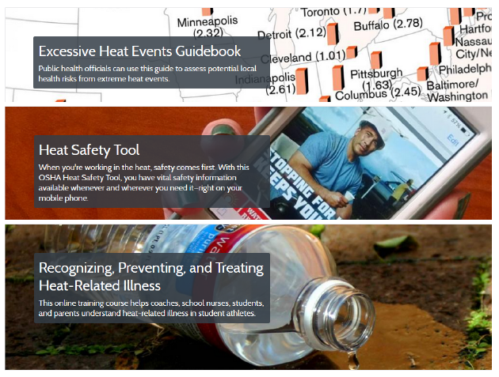

### System for Integrated Modeling of Metropolitan Extreme Heat Risk (SIMMER) Project

The SIMMER project is NASA funded research conducted by a multi-institutional and interdisciplinary team. Goal of project was to create an advanced methodology for assessing current and future urban vulnerability from heat waves, and to develop a system of building local capacity for heat hazard mitigation and climate change adaptation in the public health sector. Studies were conducted in Houston and Toronto. Findings from Houston reveal that more than half of summer nights qualify as high heat stress. Urban morphology, vegetation, and building materials play a role in determining urban heat islands. Houston also experiences high heat mortality in the elderly; in part because of social isolation. While heat advisories in Houston are issued at 108 F, largest volume of 911 calls occurred at ~104 F. Many factors interact to compound vulnerability. Air conditioning is not always available as a protection from heat waves. Many vulnerable people are unaware of symptoms of heat stress, and are not aware of programs such as assistance, and cooling centers.

The project also resulted in the development of a risk model. Additionally, heat health thresholds were determined. Climate adaptation tools such as the Extreme Heat Climate Inspector, were developed.

# B. Action Plan

**Juli Trtanj**

**Climate Information for Heat Health Information Systems: Action Plan**

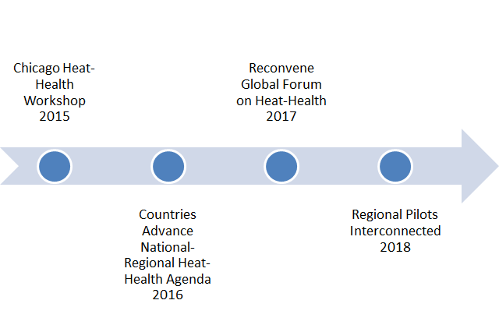

**Local-Regional Actions**

* Develop pilots of the National Integrated Heat Health Information System (NIHHIS) to sample local-regional differences in climate, vulnerability, research needs, capacity, and interventions.
  + Create and socialize NIHHIS concept to structure regional heat-health approach.
  + Engage federal partners with a stake in heat-health to harmonize approaches, and information, and develop combined capacity to prepare and respond.
  + NIHHIS pilots to be regional, with trans-boundary aspect, and focal cities.
    - Link efforts to:
      * North American Climate Services Partnership (NACSP)
      * North American Climate Change and Human Health Partnership (NACCHHP)
      * Global Framework on Climate Services (GFCS)
        + Global Climate Information System (GCIS)
      * NOAA Regional Integrated Science and Assessments (RISA) program
      * CDC Building Resilience Against Climate Extremes (BRACE) program
      * NOAA Regional Climate Services
      * USDA and DOI Climate Hubs
      * State Climatologists
  + US/Mexico Rio Grande/Bravo (RGB) NIHHIS pilot
    - Consider El Paso as hub
    - Work with Gregg Garfin to develop overall pilot, engaging CDC, UAZ, and TTU
    - Engage Mexico (highlight at GEO?)
    - Strong urban infrastructure, communication, outdoor worker, and lower-income focus.
  + Northeast US and Canada NIHHIS pilot
    - Work with Canada (Jeffers) and Olga on vulnerability maps/info
    - Consider New York City and Boston as hubs
    - Strong city planning, design, and construction capabilities
  + Midwest - Great Lakes NIHHIS Pilot
    - Consider Chicago as hub
    - Emergency management and housing / public health angles.
    - Work with City of Chicago to identify requirements for climate information on sub-seasonal, seasonal and other time scales.
    - Consider ways to connect to Canada
  + Western NIHHIS Pilot
    - Connect NWS Western Regional Pilot with California public health and California RISA
    - Develop western region Heat Impact Level (HIL) code concept within the National Weather Service.

**International Activities:**

* Launch International Heat-Health Coordination Capability by 2017 to support (re)convening of Global Forum to coordinate international heat-health efforts.
* Develop, document, and prioritize research requirements for international heat health preparedness and risk reduction.
* Develop a common portal to harmonize heat health guidance, forecasts and other tools and information.
* Develop portal to track progress in implementing heat-health actions on early warning and climate timescales for all countries.
* WMO to add heat-health priority to Climate Outlook Forums (COFs)
  + Sri Lanka in April 2016
  + Mexico in November 2016
  + Caribbean [pending]

**Multilateral Activities:**

* Follow up with India
  + Join NYC discussion in 13-17 September 2015
  + Ensure connection with Climate and Health Workshop, September 22-24, 2015, India
  + Link with NRDC’s India work to compare methods and prediction as they expand to other cities
  + Engage NOAA Monsoon desk for improved forecast
* Work with Germany to develop heat index or perceived temperature capabilities
* Work with ECDC to identify heat/VBD pilot (maybe NY-albany, or CA (Reisen)
* Work with Canada to use city/vulnerability approach in other locales (ie Rio Bravo/Grande project)
* Work with Mexico to establish heat-health activities in Mexico City Climate Outlook Forum
* Work with Bangkok, Hong Kong, and other Asian cities to establish regional heat-health capacity

**Other Ideas for follow up**

* Web portal for NIHHIS akin to NIDIS (the National Integrated Drought Information System)
* Workshop or outreach on Extreme Heat and Animals (pets and livestock)
* Plan for Follow up workshop in two years (June-July 2016) to evaluate implementation efforts stimulated or discussed at this workshop, best practices and new knowledge.
* Workshop focused on Communication of Risk and Related Decisions or Actions for Heat Health Information across time scales.
* Engage Broadcast Meteorology Community, Public Health and Emergency Management Officials to discuss the risks and benefits of communication of forecast and other heat products across time scales, to address concerns of forecast uncertainty related to health and, and the role of the media in public health preparedness and protection.
* Heat-Health Sessions at:
  + American Meteorological Society (AMS)
  + American Geophysical Union (AGU)
  + American Public Health Association (APHA)
  + International Society for Environmental Epidemiology
  + Others (especially discipline/trade specific)
* Engage Urban Climatology Community (downscaling, WRF nesting, etc…)

# C. Requirements

# **Observations and High-Level Requirements Identified during the Chicago Workshop**

### *Michelle Hawkins (NWS)*

#### **Panel 1: Extreme Heat Events - From Weather to Climate Scale Prediction**

* Emergency managers require forecasters to be more “surgical” in weather prediction and impacts; need higher resolution for different areas of the city.
  + Need: urban-scale modeling of temperature and Urban Heat Islands
* The more lead-time the better, but media hype exacerbates situation and creates multiple layers of work.
  + Need: integrated predictions with proper confidence intervals and skill information to prevent ‘crying wolf’
* Important to bridge the gap between weather and climate timescales so there is enough lead time for necessary interventions.
  + Need: intuitive and understandable information that bridges deterministic and probabilistic predictions
* Link between climate and health sectors is weaker than others (hydro and health, others).
  + Need: to build partnership, shared understanding, and co-developed information between climate and health sectors. Climate experts become fluent in health science and health experts must become fluent in climate science.
* Climate and health are merely two disciplines that exist in this space, but it is a problem requiring transdisciplinary understanding and action.
  + Need: more interdisciplinary graduates.
  + Need: integrated problem solving and decision-making across disciplines
* There are many attributes and parameters of heat waves, and they are all variable. We need to understand how these attributes and parameters influence health at all timescales and to achieve agreement on how and when to apply them flexibly - regions differ.
  + Need: understand the array of parameters and which ones are important for anticipating health outcomes in a variety of climates and conditions [temperature (max, min, avg, percentile), humidity, solar exposure, wind speeds, urban climatology, social variables, adaptive capacity]
  + lag times
  + duration
  + intensity
  + frequency
  + seasonality
  + character (humidity, solar exposure, wind)

#### **Panel 2: Public Health Decisions Across Time Scales**

* Public health decisions and activation of response plans require short term information 2-3 days, up to 5-7 days for communications and preparedness.
  + Need: improved understanding and communication of heat-health thresholds, parameters, and interventions at the emergency management time scale.
* Public health also needs decadal information at 10-50 year timeframes for city planning (infrastructure, green space, etc).
  + Need: reliable, fine-scale information about the many attributes of heat waves at climate time scales.
  + Need: climatological heat information to trigger the development of heat plans for areas where no plans currently exist.
* The Seasonal-Subseasonal (4-6 week) lead time useful for the military to plan training exercises. Military applications often require Heat Index rather than solely temperature.
  + Need: reliable predictions at the S2S time scale that can be trusted enough to modify training schedules and other outdoor events (athletics).
  + Need: S2S scale humidity information to couple with temperature and create Heat Index information.
  + Need: planning policies which may be responsive to relative risk of heat-induced hospital visits.
* Public health requires seasonal information to prepare well in advance
  + Need: information to develop plans to increase number of cooling centers, optimize placement, and pre-position mobile assets.
  + Heat wave probability by month can be used to plan staffing levels.
* Given that people are expected to experience stronger and longer heat waves, public health will need information above current extremes to gauge projected increases.
* Duration of heat waves above a threshold temperature is a clear indicator of time-lagged heat deaths, suggesting a need for this information at all timescales to prepare for both imminent heat waves and climate-scale heat wave statistics.
* There are many approaches to reducing heat risk being employed around the world.
  + Need: a catalog of heat-health interventions with robust information about effectiveness, cost to implement, viability in future climates, implementation methods.
* Public Health Surveillance and Climate Prediction are both important components of early warning and risk reduction but they are actions conducted by different communities
  + Need: to couple surveillance and climate prediction to develop an integrated approach to early warning for heat waves

#### **Panel 3: Heat Exposure and Health Outcomes**

* Many Heat Health Early Warning Systems (HHEWS) are in operation, but the effectiveness of the systems is difficult to measure
  + Need to establish methods and protocols for studying the effectiveness of HHWS – one way is to design case control studies that assess the impact of HHWS on mortality and morbidity.
* Mortality is but one adverse health outcome from extreme heat.
  + Need: capture the entire set of health outcomes due to extreme heat, including morbidity, exacerbation of chronic conditions (asthma), reduced labor productivity and lost work days, rescheduling costs or avoidance costs, etc...
* ICD codes only capture simplified cause of death and morbidity information
  + Need: to influence coding norms to include documentation of extreme-heat induced deaths which may be coded with other ultimate proximate causes
  + Need: to discover additional information sets for evaluating heat-health connections including ambulance documentation, military databases, patient noted that are narrative and not coded, OSHA logs.
* Communicating early warning information is complex and doesn’t automatically induce preventative behaviors in at-risk populations.
  + Need: evaluate different weather metrics, but also response and prevention strategies that may be independent of weather metrics.
  + Need: help from social scientists and evidence-based studies to identify effective communication strategies.
  + Need: more dialogue and collaboration when there are many states/areas under heat alerts to reduce confusion.
  + Need forecasters to be able to communicate health impacts provided by public health officials.

**Modeling and Prediction Breakout Summary**

* Need to identify users and specific needs – different users have different vulnerabilities and needs. Different risk models are needed for different groups.
* Need more localized modeling and prediction information.
* Need to identify the most acceptable lead time.
* Need climate information that can give useful guidance in the absence of skillful models.
* Modeling and prediction of health impacts are needed.

**Exposure Risk Breakout Summary**

* Finer resolution information is required to address community scale impacts.
  + Fine special scale information is needed to identify impacts on vulnerable communities.
  + Need more observations within cities (instead of airports).
  + Models need to be calibrated and validated for different cities.
  + Indoor environments and lack of AC is important to model, along with micro climates around neighborhoods.
  + Need 10yr period of data to do exposure studies at 1km resolution in cities.
* Need to be able to validate health models with health data.
* Need to understand the needs of different sectors: Public health doesn’t want to provide information until very close to the event because they want it to be fresh on the minds of the impacted community. Other sectors might be able to use a week-2 forecast (agriculture, sports coaches/clinicians, water resource planners, etc). Every sector needs information at different time scales, which will have a different level of uncertainty.
* Need interpretation services of entire suite of forecast products and data.
* Need to present uncertainty in different formats for different audiences.
* Need to use and assimilate current data – On example is to use 10yr of WRF 1K data, validated against observations to project backwards and do an epidemiological study to identify how health is impacted by temperature.

**Observations & Surveillance Breakout Summary**

* Need to integrate observations and socio economic vulnerabilities.
* Need humidity climatology.

**Requirements Identified During the Town Hall**

* Emergency Management
  + Primarily need short-term information. With 50-70% accuracy they can make decisions.
  + Long-term and seasonal information with 6-months lead time would be useful for strategic planning.
* Public Health
  + In the face of uncertainty they need to remain a credible source of health information.
* Media
  + Higher resolution, storm scale modeling is required to accurately notify impacted communities.

# D. Appendices

## References

Anderson, G. B., & Bell, M. L. (2011). Heat Waves in the United States: Mortality Risk during

Heat Waves and Effect Modification by Heat Wave Characteristics in 43 U.S. Communities. *Environmental Health Perspectives*, *119*(2), 210–218.<http://doi.org/10.1289/ehp.1002313>

Azhar, G. S., Mavalankar, D., Nori-Sarma, A., Rajiva, A., Dutta, P., Jaiswal, A., … Hess, J. J.

(2014). Heat-Related Mortality in India: Excess All-Cause Mortality Associated with the 2010 Ahmedabad Heat Wave. PLoS ONE, 9(3), e91831. [doi:10.1371/journal.pone.0091831](http://journals.plos.org/plosone/article?id=10.1371/journal.pone.0091831)

Ebi, K. L., Teisberg, T. J., Kalkstein, L. S., Robinson, L., & Weiher, R. F. (2004). Heat

watch/warning systems save lives: estimated costs and benefits for Philadelphia 1995-98. Bulletin of the American Meteorological Society, 85(8), 1067-1073. [*http://dx.doi.org/10.1175/BAMS-85-8-1067*](http://dx.doi.org/10.1175/BAMS-85-8-1067)

Jendritzky, G., H. Staiger, K. Bucher, A. Graetz, and G. Laschewski. "[The perceived](http://www.utci.org/isb/documents/perceived_temperature.pdf)

[temperature: the method of the Deutscher Wetterdienst for the assessment of cold stress and heat load for the human body.](http://www.utci.org/isb/documents/perceived_temperature.pdf)" In *Internet workshop on Windchill*, vol. 3, no. 07. 2000.

Kalkstein, L. S., Jamason, P. F., Greene, J. S., Libby, J., & Robinson, L. (1996). The

Philadelphia hot weather-health watch/warning system: development and application, summer 1995. Bulletin of the American Meteorological Society, 77(7), 1519-1528. [http://dx.doi.org/10.1175](http://journals.ametsoc.org/doi/abs/10.1175/1520-0477%281996%29077%3C1519%3ATPHWHW%3E2.0.CO%3B2)

Knowlton, K., Kulkarni, S., Azhar, G., Mavalankar, D., Jaiswal, A., Connolly, M., … the

Ahmedabad Heat and Climate Study Group, E. (2014). Development and Implementation of South Asia’s First Heat-Health Action Plan in Ahmedabad (Gujarat, India). IJERPH, 11(4), 3473–3492. [doi:10.3390/ijerph110403473](http://www.mdpi.com/1660-4601/11/4/3473)

Nairn, J. & Fawcett, R. (2014). The Excess Heat Factor: A Metric for Heatwave Intensity and

Its Use in Classifying Heatwave Severity. IJERPH, 12(1), pp.227–253.<http://dx.doi.org/10.3390/ijerph120100227>.

Saha, S., Brock, J. W., Vaidyanathan, A., Easterling, D. R., & Luber, G. (2015). Spatial

variation in hyperthermia emergency department visits among those with employer-based insurance in the United States – a case-crossover analysis. *Environmental Health, 14(20),* [*doi: 10.1186/s12940-015-0005-z*](https://ehjournal.biomedcentral.com/articles/10.1186/s12940-015-0005-z)

Valentine, K. (2015, August 10). Extreme Heat Leads To Deaths, Protests In The Middle

East. *Think Progress.* Retrieved from: [http://thinkprogress.org/climate/](https://thinkprogress.org/extreme-heat-leads-to-deaths-protests-in-the-middle-east-cfdb5faf7cef)

Walsh, J., D. Wuebbles, K. Hayhoe, J. Kossin, K. Kunkel, G. Stephens, P. Thorne, R. Vose,

M. Wehner, J. Willis, D. Anderson, S. Doney, R. Feely, P. Hennon, V. Kharin, T.

Knutson, F. Landerer, T. Lenton, J. Kennedy, and R. Somerville, 2014: [Ch. 2: Our Changing Climate](http://nca2014.globalchange.gov/report/our-changing-climate/extreme-weather). Climate Change Impacts in the United States: The Third National Climate Assessment, J. M. Melillo, Terese (T.C.) Richmond, and G. W. Yohe, Eds., U.S. Global Change Research Program, 19-67. doi:10.7930/J0KW5CXT.

## 